C2 HILS ALICANTE FEBRUARY 03/07 2020 AGENDA 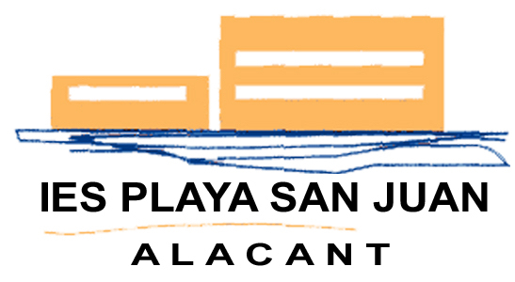

 | MONDAY 03 | TUESDAY 04 | WEDNESDAY 05 | THURSDAY 06 | FRIDAY 07
08:00 | Students’ first contact  AWAKE GAMES  AUM | Students: AWAKE GAMES  AUM | Students: AWAKE GAMES  AUM | 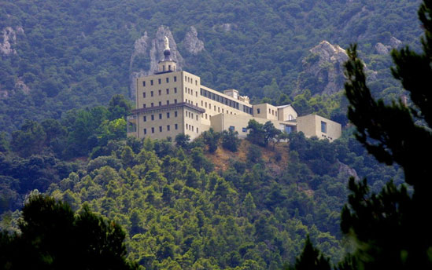  AUM  On charge:  One teacher per team | Students: AWAKE GAMES  AUM
08:30 | “  On charge:  One teacher per team | “  On charge:  One teacher per team | “  On charge:  One teacher per team | All students/All Staff  By bus, from school:  Excursion.  Natural Park Font Roja.  http://www.parquesnaturales.gva.es/es/web/pn-font-roja  Track:  https://es.wikiloc.com/rutas-senderismo/menejador-desde-la-font-roja-itinerario-amarillo-42424180  All students/All Staff | “  On charge:  One teacher per team
09:00 | Placing ourselves at school  All Students/Staff | “ | By bus, from school:  Resource Center  ONCE Organization  (The National Organization of the Spanish Blind)  All students/All Staff | “
09:30 | Welcome meeting  AUM | By bus, from school:  Museum “The Ocean Race” Volvo.  https://www.museotheoceanrace.com/  ONLY VGGM + Enfield Council: Visit to C14:  (Youth Resource Center of the Alicante City Council.  Project Collaborating Organization)  Calle Virgen de Belén, 11, 03002 Alicante  All students/All Staff | 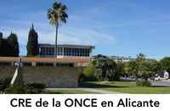 | “ | Working meeting  Staff  LIBRARY  ***  Evaluation will be  available on line
10:00 | Students’ presentations  AUM | 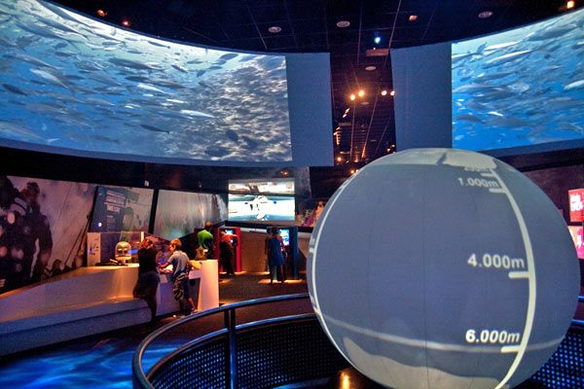 |  | “ | Students: AWAKE GAMES final proposal
10:30 |  |  |  |  | “
11:00 |  |  |  |  | Coffee break  Staff  Students: free time
11:30 |  |  | Back to school |  | Certificates
12:00 | Coffee break  Staff  Students: free time | Coffee break  Staff  Students: free time | Coffee break  Staff  Students: free time |  | Enfield/VGGM WORKSHOP  Cooperative games  Students/ One teacher p team
12:30 |  | Sailing activities (Students/Staff)  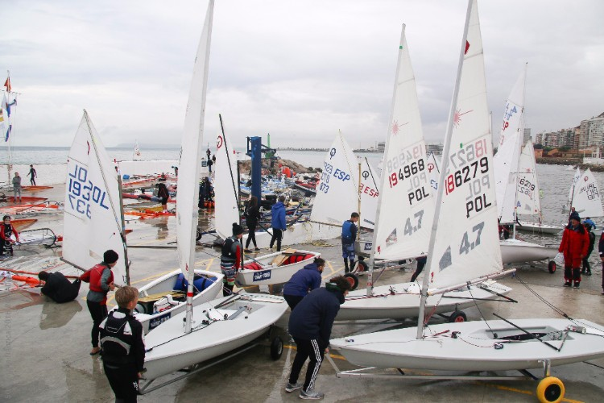  All students/All Staff | Enfield/VGGM WORKSHOP  “Sport Leadership”  Students/One teacher per team  GYM  Working meeting  Staff  LIBRARY
13:00 | 13:15  Yoga Workshop  Students/Staff  GYM |  | Enfield/VGGM WORKSHOP  “Sport Leadership”  Students/One teacher per team  GYM  Working meeting  Staff  LIBRARY | LUNCH:  All Staff/all students  LUNCH  RESTAURANTE FUENTE ROJA  https://goo.gl/maps/bfMwG7Pz75GYXPaVA
13:30
14:00 |  |  |  |  | DANCE:  WORKSHOP +EXHIBITION: Bachata  Students/Staff  GYM
14:30 |  |  |  | Back to school
15:00 | End of activities | Back to school/End of activities | End of activities | End of activities | End of activities  15:15  Lunch (Staff)  TO-BAR ALBUFERETA  https://goo.gl/maps/Q9eieRH3KJJQGk4M7
 | Free Time
19:00 |  |  |  |  | Farewell Party (Students/Staff)  HOTEL CASTILLA
20:30 | Evening meal (Staff)  RESTAURANTE NOU DELFIN  https://g.co/kgs/WRJXw6 | Evening meal (Staff)  RISTORANTE SIMONE  https://goo.gl/maps/NvT2CgDRbnfG9oxN7 | Evening meal (Staff)  MY RESTAURANTANT  https://g.page/my-restaurant-alicante?share | Evening meal (Staff)  RESTAURANTE LOS PACOS  https://maps.app.goo.gl/5f8rNx694LZTvKMYA

